PACKAGE MANAGEMENT IN LINUX & USER ADMINISTRATION

Q1. Create a user with name edu,having full name as edureka,home directory set to /home/edureka, and whose primary group should be edureka

ANSWER : 

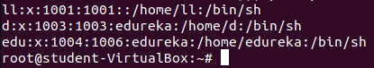 question?

Q2. How will you display the user id and groups of user edu created in the above

ANSWER :

Q3. How will you set the password of user educreated in step above?

ANSWER: 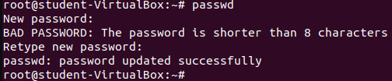

Q4. How will you install an httpd package on the linux machine?

ANSWER: yum inshell httpd –y

Q5. How will you check if you have the ssh package installed on the

server or not?

ANSWER : rpm –qa |grep –I sshd

Systemctl status sshd